

ISSRT Mini Newsletter

Pre-conference Edition

horizontal lineEditors: Holly Heisner & Patti Holveyhorizontal line

# 87th Annual Spring Conference

April 6-8th, 2022



A WORD FROM THE CONFERENCE CHAIRMAN

We are back! Please join us again for the I.S.S.R.T. Annual Conference at the DoubleTree Hotel in Bloomington Illinois. The conference will take place April 6-8, 2022. We have a great group of presenters waiting to present to you. Some of the topics are “Babbling Brainstorms to Professional Portfolio”, “You Thought Physics Had To Be Boring”, “How Did I Get Stuck With You”, and many more. Get ready for a Kahoot Challenge, panel discussions, and a chance to see old friends that we have not seen in over two years. Of course, the Scholar Bowl will be back with new questions and a chance to root on your college. Everybody’s “happy place” the Silent Auction will be offering baskets, gift cards, and other items for you to bid on against your fellow students and instructors.

We are planning a great conference for you and our guests. We hope you will join us in Bloomington on April 6-8, 2022. Please register now for the conference, hotel rooms, and your scholar bowl team….. Information on how to do this is in this newsletter.

We can “Make A Difference” see you soon.

Patrick Murphy & Tim Cuff

2022 Annual Conference Chairmen

horizontal line

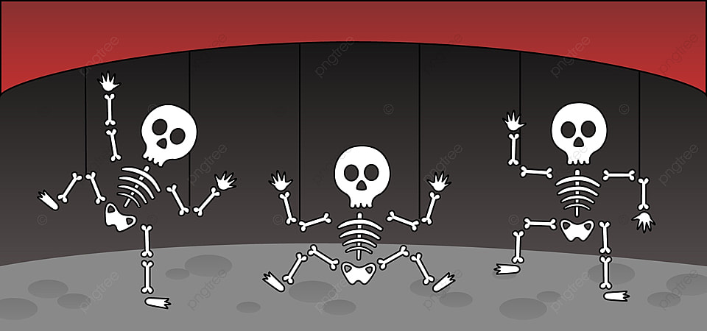

CONFERENCE DETAILS

<https://www.issrt.org/conference/registration/>

**Registration Costs:**

Technologist Member- $125.00

Technologist Non-Member-$175.00

Student Member- $75.00

Student Non-Member-$100.00

Technologist Member- Single Day-$40

Technologist Non-Member- Single Day-$90

**Hotel Reservations:**

Each individual or College is responsible for making their own reservations with the DoubleTree by Hilton.

*Please reference the dates and the IL State Society of Radiologic Technologists when booking. Please book by March 16th, 2022.

<https://www.hilton.com/en/attend-my-event/bmidtdt-irt-2cf5cd3c-8fbd-40f6-956d-84aa7e777be4/>

Hotel Information:

10 Brickyard Drive

Bloomington, IL 61701

Phone #: 309-664-6446

**CONFERENCE SCHEDULE**

Stay tuned for the final draft of the conference schedule which will be posted online as well as on social media. Below is the tentative schedule of events:

|  |  |
| --- | --- |
| ***Wednesday*** |  |
| *8:30-9:30* | *Registration* |
| *9:30-10:00* | *Announcements/Business Session* |
| *10:10-11:10* | *“How Did I get stuck with you” Presented by Diane Hutton* |
| *11:20-12:30* | *Student Presentations* |
| *12:30-1:00* | *Lunch* |
| *1:10-2:10* | *“Advocacy in Radiology” Presented by Scott Hugland* |
| *2:20-3:20* | *“Importance of Contrast Media in CT” Presented by Jennifer Walker* |
| *3:20-3:45* | *Break* |
| *3:55-4:55* | *“Babbling Brainstorm to Professional Radiology Portfolio” Presented by Patti Holvey* |
| *7:30-9:30* | *Evening Event-Trivia Night* |
| ***Thursday*** |  |
| *6:30-9:00* | *Breakfast (provided)* |
| *8:30-9:30* | *“Safety in MRI” Presented by Jennifer Walker* |
| *9:40-10:40* | *“The Bizarre Side” Presented by Bill Callaway* |
| *10:50-12:30* | *Scholar Bowl* |
| *12:30-1:00* | *Lunch (provided)* |
| *1:00-2:00* | *Kahoots-ASRT Question Review-Sharon Elwood to facilitate* |
| *2:15-3:30* | *Business Session/Installation of Officers/President Message/50/50 Drawing* |
| *3:30-4:15* | *Special Treat Break* |
| *4:20-5:20* | *“And you Thought Physics Had to be Boring” Presented by Bill Callaway* |
| ***Friday*** |  |
| *6:30-9:00* | *Breakfast (provided)* |
| *8:15-9:00* | *Educators Meeting* |
| *9:00-10:00* | *“Ethics and Legal Issues in Radiologic Science” Presented by Brandon Hirsch* |
| *10:15-11:15* | *Awards(Scholarship, Essay,E-Poster)/Vendor Drawing/50/50 Drawing* |
| *11:30-1:00* | *Scholar Bowl Finals//Closing Remarks* |

Student E-Poster/Research Paper Deadline is March 15th

Hey Students! Have you had to put a lot of blood, sweat and tears into an excruciatingly long and detailed research paper or ePoster? Want to make all of that hard work and diligent effort pay off? Then why not enter that amazing bit of scientific research in the ISSRT ePoster and the ISSRT Research Paper Competitions? The ISSRT has even sweetened the deal and raised the cash prizes!

***2022 ISSRT ePoster Competition prizes for 1st, 2nd and 3rd: $150, $100, and $75 respectively.***

***2022 ISSRT Research Paper Competition prizes for 1st, 2nd and 3rd: $200, $150, and $100 respectively.***

And yes, you can enter both!

To find out more, please visit the ISSRT website at [***issrt.org***](https://www.issrt.org/) or follow the links below to find the applications and detailed information regarding the competitions. Deadline dates for entry is March 15th, 2022.

[***ISSRT Student Research Paper Competition***](https://www.issrt.org/conference/student-research-papers/)

[***ISSRT Student ePoster Competition***](https://www.issrt.org/conference/eposter-competition/)

So make your hard work and effort pay off even more, enter the ISSRT ePoster and Research Paper Competitions today!

SILENT AUCTION

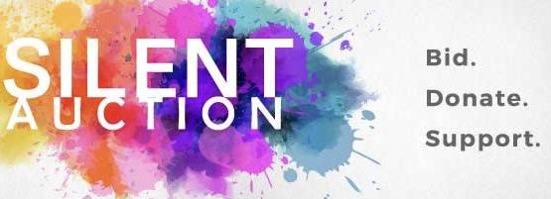

Hello ISSRT Members! Preparations are underway for the 2022 Annual Conference and the ever popular Silent Auction!

We are asking for donations of items to be raffled off in the silent auction. The proceeds from the silent auction go toward ISSRT scholarships, to benefit student and RT members.

Some items in the past have included:

Corn Hole Games, Wine Baskets, Jewelry, tickets to sporting events…

The options are limited only to your imagination! Get those thinking caps on and let your imagination go wild!

Here is the link to an link to submit your Auction item information:<https://www.issrt.org/conference/silent-auction-submission/>

Email Cathie Kukec

[issrt.cob@gmail.com](mailto:issrt.cob@gmail.com)

**SCHOLAR BOWL**

The annual scholar bowl competition is set to resume this year.

Below are the highlights of what your team will need to know!

* - Team registration is $60 per team.
* - Team registration deadline is April 1st. No exceptions!
* - There will be no team registration accepted after this date.
* - Faxed registrations will not be accepted.
* - Team members listed above must be a member of the ISSRT prior to registration and must register for the conference.
* - Documentation for membership status must accompany registration.

Team Sign-Ups can take place here: <https://www.issrt.org/conference/scholar-bowl/>

HAVE A BUSINESS? BECOME A SPONSOR

<https://www.issrt.org/conference/vendors/>

horizontal line

|  |
| --- |
| [**READ MORE ON OUR WEBSITE**](http://issrt.org) |

**Are you following us on social???**

**Stay tuned for some friendly competition that will take place at this year's conference. You don’t want to miss out!!**

Facebook - @ISSRTIL

Instagram - issrt.media

Twitter - @ISSRT1

Linkedin:[linkedin.com/in/issrt-ill-state-society-of-rad-technologists-790045191](https://www.linkedin.com/in/issrt-ill-state-society-of-rad-technologists-790045191)



